**Department of Artificial Intelligence**

**College of Computer and Cyber Sciences**

**Introduction to Deep Learning**

***Neural Network Design, Training, and Evaluation with PyTorch***

1. **Learning Objectives**

By the end of this lab, students will:

* Define and Implement a **Neural Network** Model.
* **Train**, **Test**, and **Evaluate** the Model.
* Explore Deep Learning **Datasets**.

1. **Lab Requirements**

Software:

* Python or Anaconda Jupyter notebook.
* PyTorch.
* CUDA.

Hardware:

* Students should use the lab devices for running their deep learning models.

1. **Explanation of Key Concepts**

* **CPU vs GPU:**

CPU (Central Processing Unit): The brain of the computer, handling general tasks like running software, browsing, and multitasking. It has a few powerful cores optimized for sequential processing. Good for general computing and logic-based tasks.

GPU (Graphics Processing Unit): Designed for heavy parallel tasks like gaming, video editing, and AI computations. It has many smaller cores that process multiple tasks simultaneously, making it much faster for specific workloads. Best for graphics, AI, and tasks requiring high-speed parallel processing.

* **MNIST Dataset:**

The MNIST dataset (Modified National Institute of Standards and Technology dataset) is a large collection of handwritten digits (0-9) used for training and testing machine learning models, especially in image recognition and deep learning.

Key Features of MNIST:

Size: 70,000 images (60,000 for training + 10,000 for testing).

Image Format: 28x28 pixels, grayscale (black & white).

Labels: 10 classes (digits 0 to 9).

1. **Activities**

* **Exercise 1: Training on MNIST.**

Train a PyTorch model on the Mnist dataset using GPU.

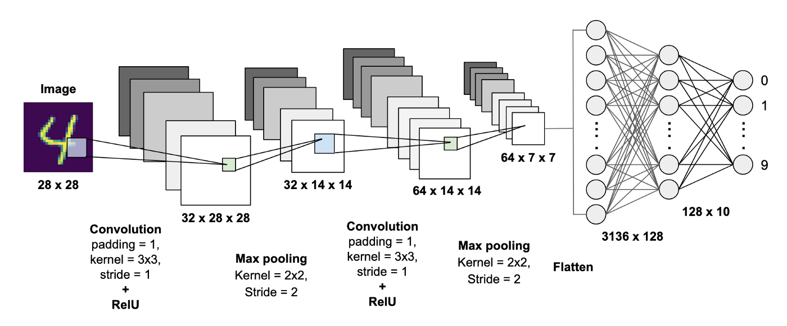

|  |
| --- |
| # Code provided in the notebook |

Screenshot of the result:

|  |
| --- |
|  |

1. **Tasks**

* **Task 1:**

Train the same model provided in Exercise 1 with the CIFAR-10 dataset and add comments to all functions in the notebook:

Add your code here (or just submit your jupyter notebook):

|  |
| --- |
|  |

Screenshot of the result:

|  |
| --- |
|  |

1. **References**

[CPU vs. GPU: What's the Difference?](https://www.intel.com/content/www/us/en/products/docs/processors/cpu-vs-gpu.html)

[MNIST - Ultralytics YOLO Docs](https://docs.ultralytics.com/datasets/classify/mnist/)

[examples/mnist/main.py at main · pytorch/examples](https://github.com/pytorch/examples/blob/main/mnist/main.py)

[CIFAR-10 and CIFAR-100 datasets](https://www.cs.toronto.edu/~kriz/cifar.html)